Adding Navigation

Christine Hodges

Rasmussen College

Author Note

This paper is being submitted on April 29th, 2018 for Professor Darice Corey’s CIS3801 Fundamentals of Mobile Web Application Development Course.

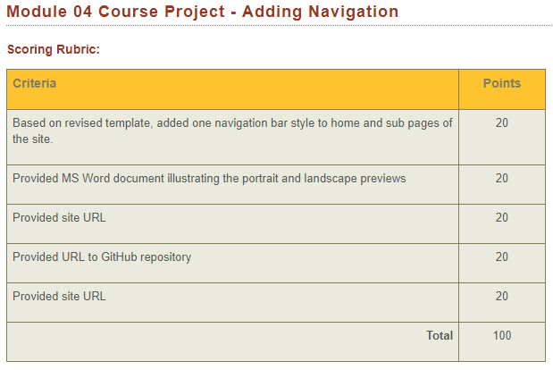

**Added one navigation bar to home and subpages of website:**

Index: <http://chodgeswebappdev.centralus.cloudapp.azure.com/Module_04/Module_04/index.html> 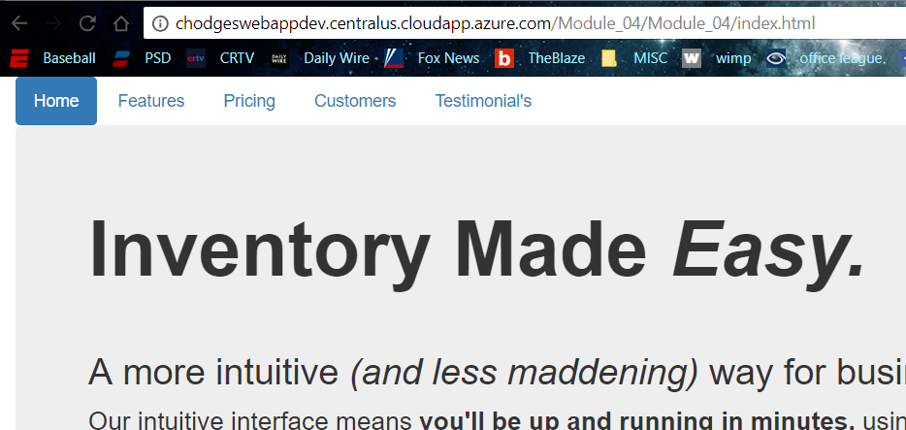

Features page: http://chodgeswebappdev.centralus.cloudapp.azure.com/Module_04/Module_04/page1.html

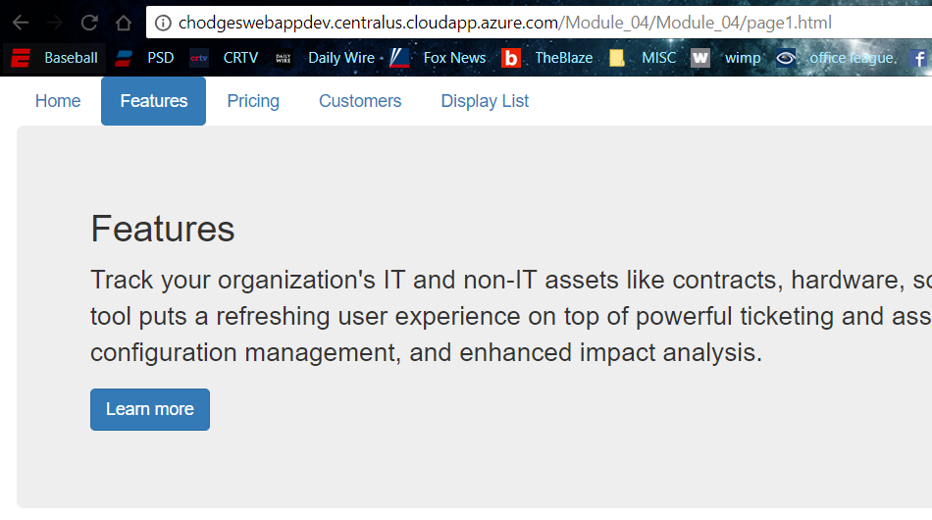

Pricing: <http://chodgeswebappdev.centralus.cloudapp.azure.com/Module_04/Module_04/page2.html>

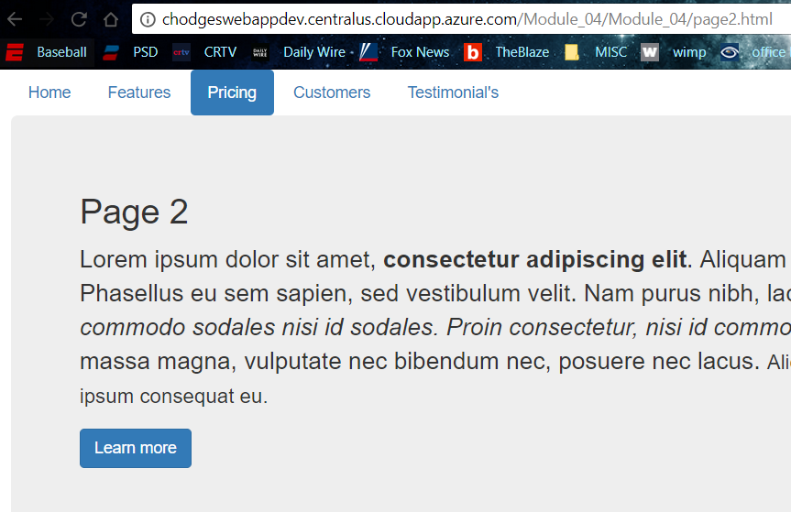

Customers: <http://chodgeswebappdev.centralus.cloudapp.azure.com/Module_04/Module_04/page3.html>

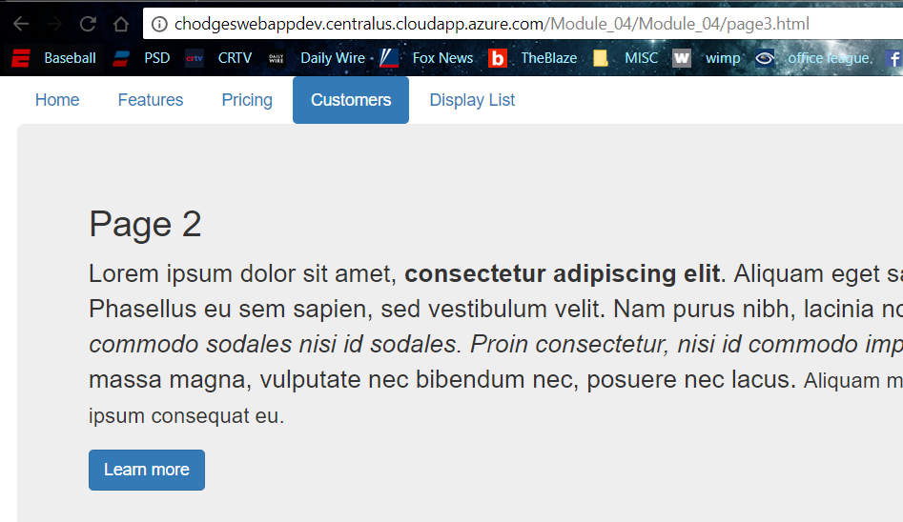

Testimonial’s: <http://chodgeswebappdev.centralus.cloudapp.azure.com/Module_04/Module_04/mod3_displaylist.php>

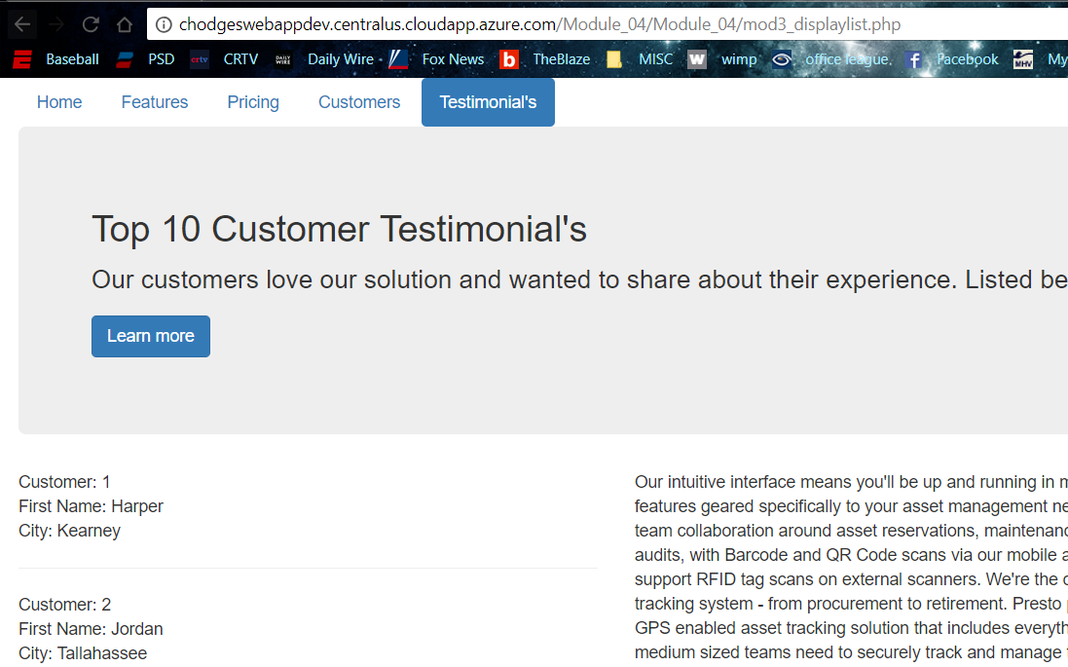

**Provide illustration showing landscape or horizontal previews:**

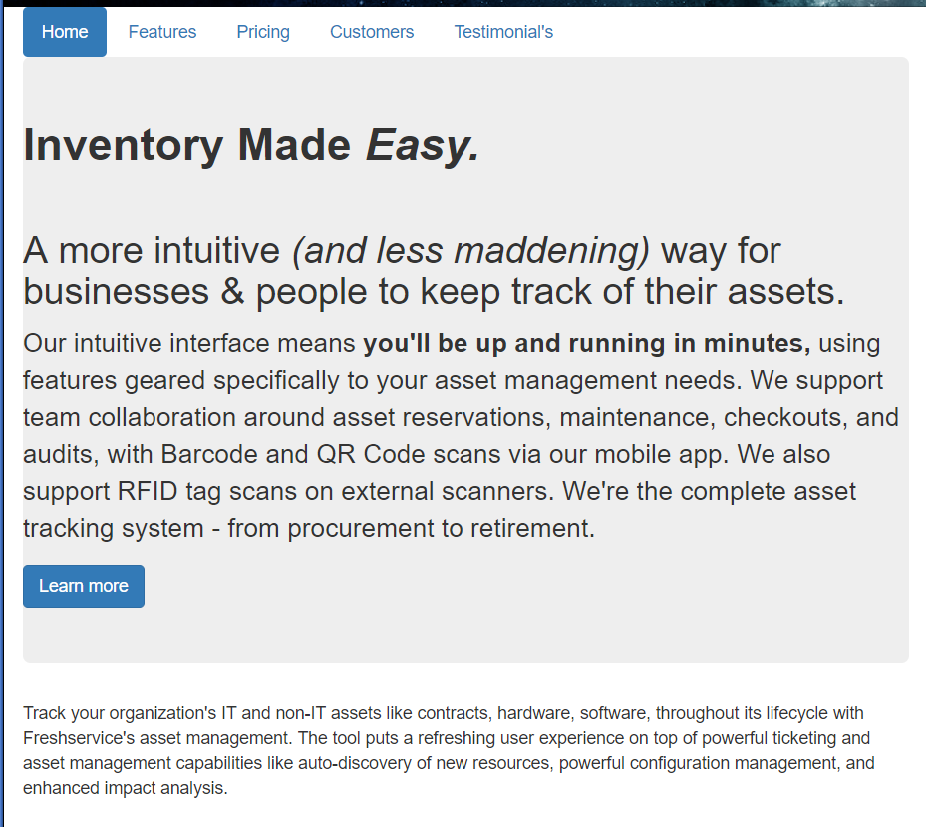

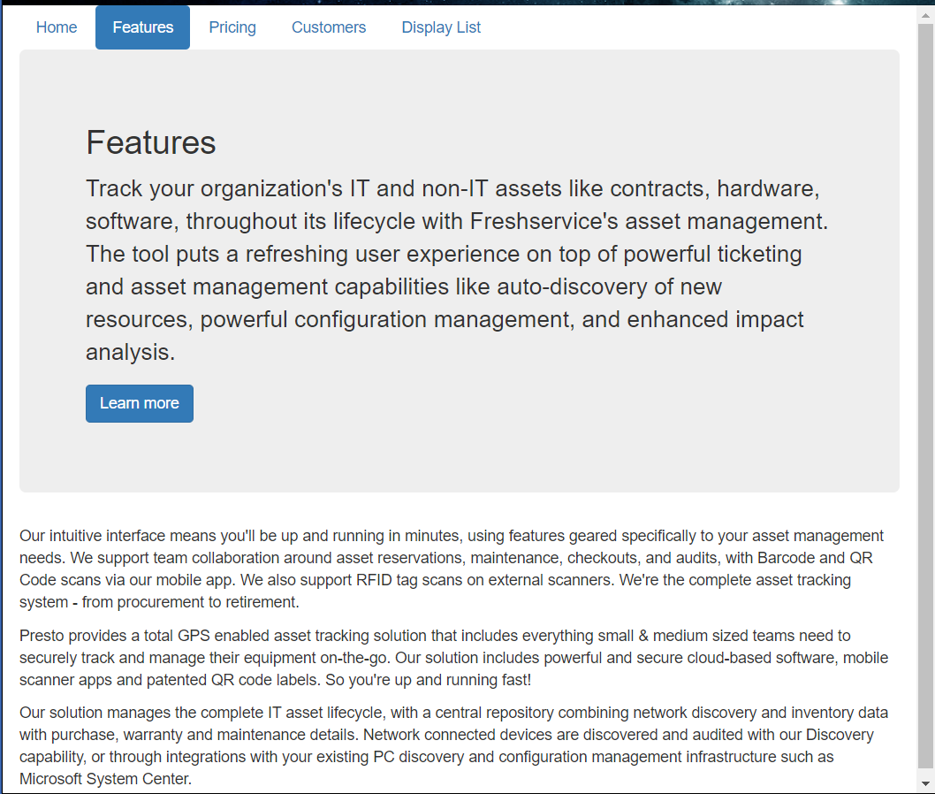

**Provide index URL:**

<http://chodgeswebappdev.centralus.cloudapp.azure.com/Module_04/Module_04/index.html>

**Provided URL to GitHub Repository:**

<https://github.com/fitactivemomgineer/Module_04-Adding-Navigation>

**Provided site URLs:**

<http://chodgeswebappdev.centralus.cloudapp.azure.com/Module_04/Module_04/index.html>

<http://chodgeswebappdev.centralus.cloudapp.azure.com/Module_04/Module_04/page1.html>

<http://chodgeswebappdev.centralus.cloudapp.azure.com/Module_04/Module_04/page2.html>

<http://chodgeswebappdev.centralus.cloudapp.azure.com/Module_04/Module_04/page3.html>

<http://chodgeswebappdev.centralus.cloudapp.azure.com/Module_04/Module_04/mod3_displaylist.php>